Create login gourp in postgresql:

* Login/Group Roles > Create – Login/Group Role :

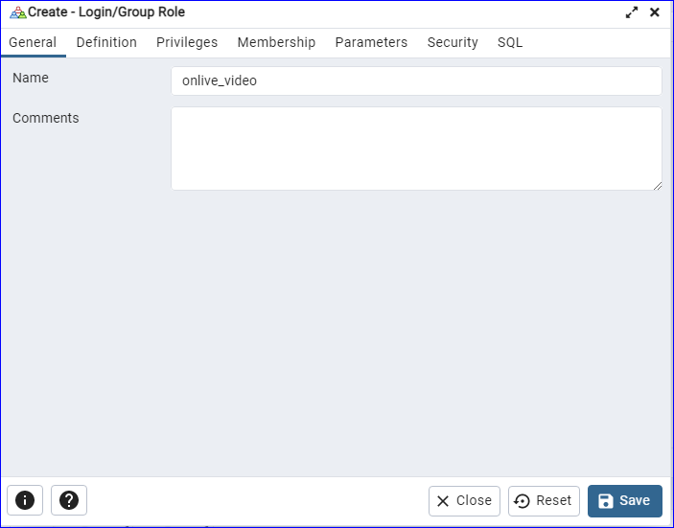

>Definition: password : onlive_video

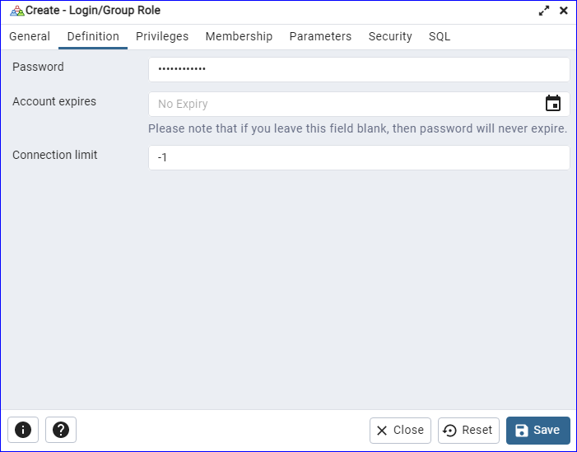

>Privileges: Open Sql can access

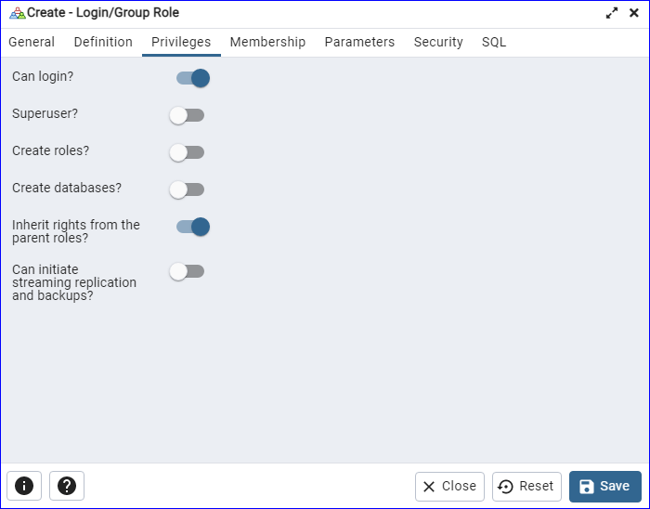

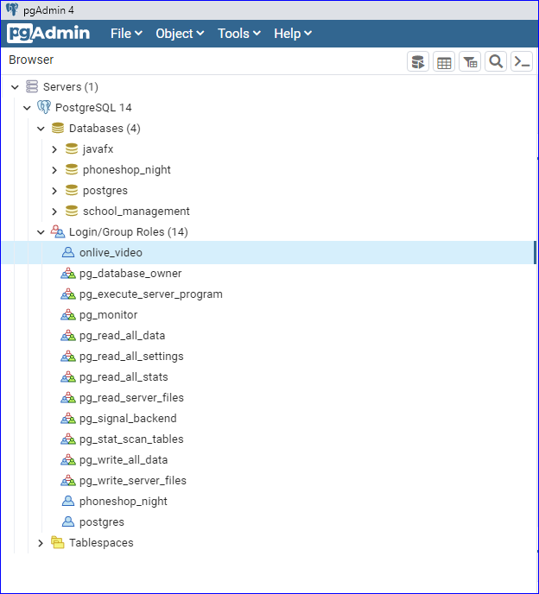

>Create Database:

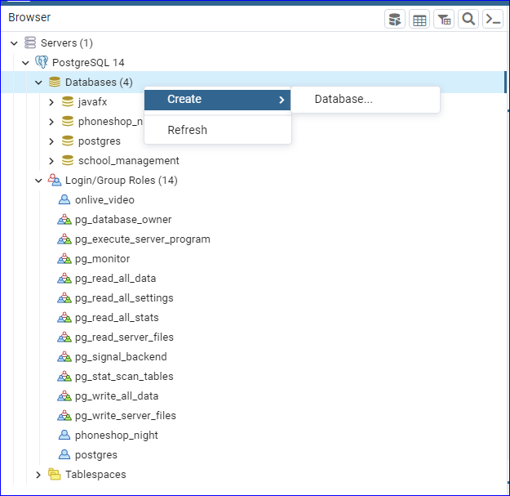

>Databases>Create>Database

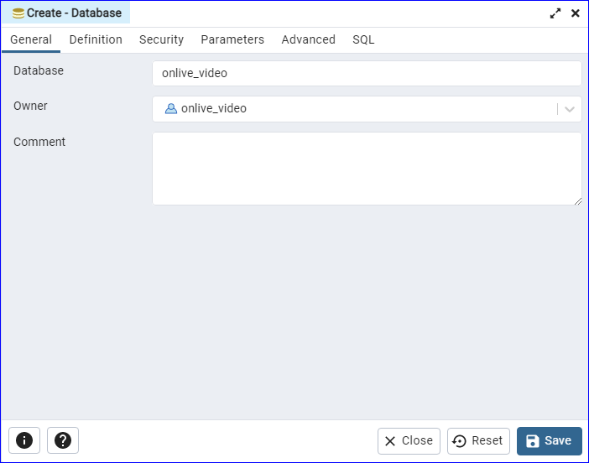

>update sequences:

DELETE FROM course;

SELECT setval('course_id_seq', 1); update sequences